Project Development Phase
Performance Test

Date | 19 February 2026
Team ID | LTVIP2026TMIDS24859
Project Name | Calculating Family Expenses using Service Now
Maximum Marks

Model Performance Testing:
Project team shall fill the following information in model performance testing template.
S.No. | Parameter | Screenshot / Values
1. | Form Loading Performance | 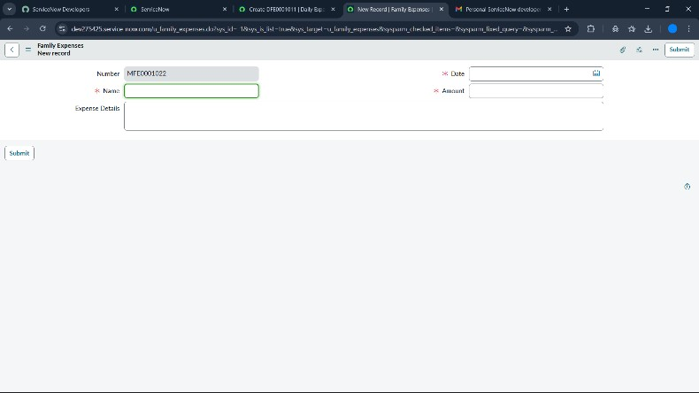
2. | Record Creation Performance | 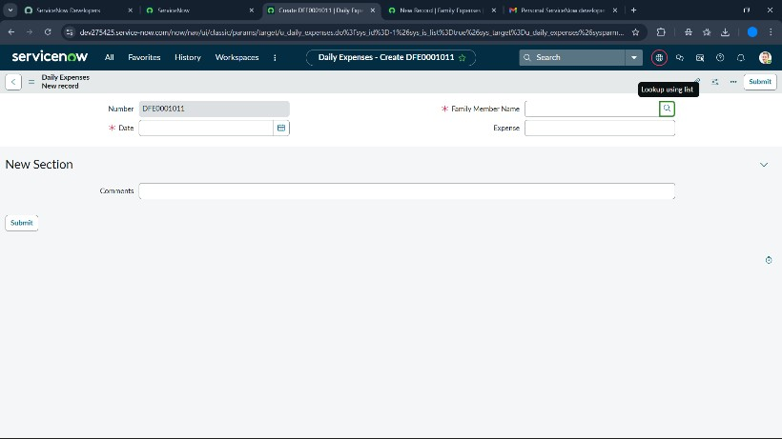
3. | Business Rule Execution | 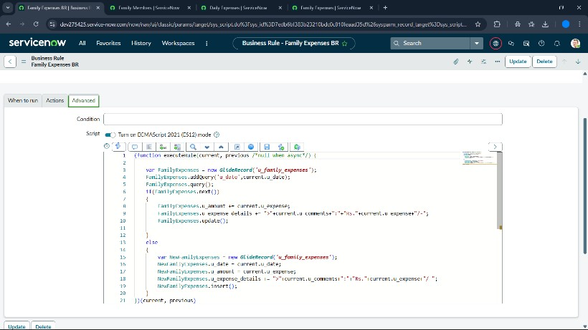
4. | Related List Loading Performance | 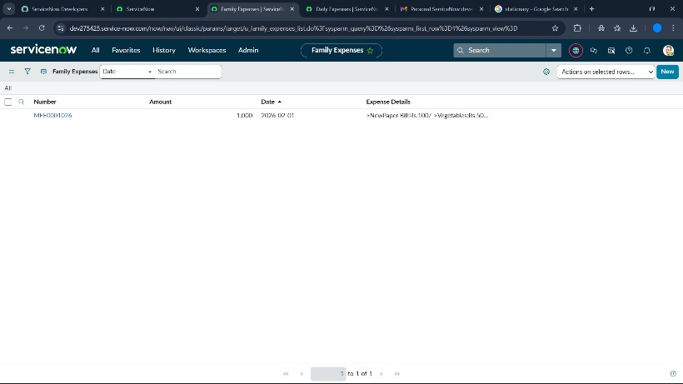
5. | Record Retrieval | 